Statistics Lecture 6.2: Introduction to the Normal Distribution and Continuous Random Variables

Studying of a continuous random variable.

If the continuous random variable has a symmetric bell shaped curve, it is considered to have a
normal distribution.

Uniform distribution
All values have the same probability of occurring.

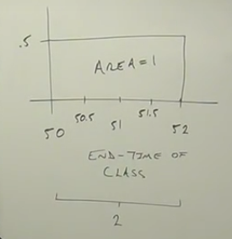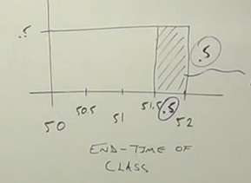

“Finding the probability of a range of values”

To find the probability of a density curve Rules
- Area=1
- Height for each value must be greater than or equal to zeros and less than or equal to 1
(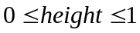)

Area = 1 (Total probability)
Width = 2 minutes
Area = width times height.
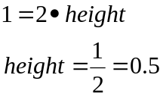

The probability of leaving this class room between 50 thru 52 minutes is the same.
See above chart.
Probability of a specific time is zero for a class ending

Find the probability that the class will end between 51.5 and 52.0
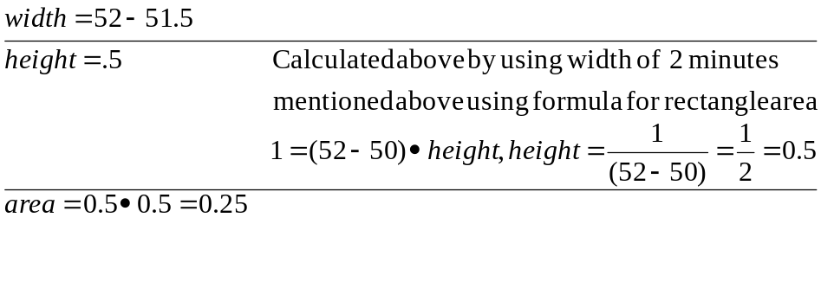

Normal distribution:
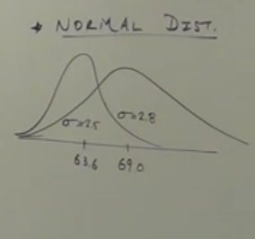
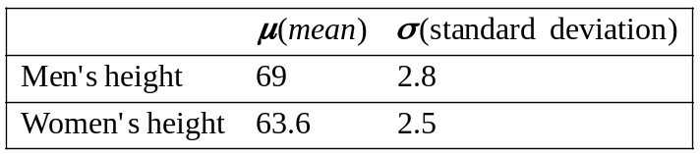

Standard Normal Distribution.
Simplifies normal distributions.
Forces mean to be 0, the standard deviation to be 1 and the area = 1

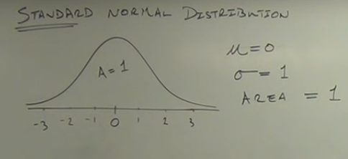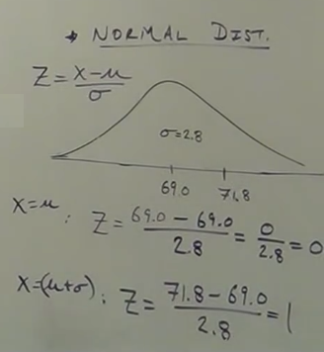

Translate normal distribution to a standard normal distribution.

Z-score
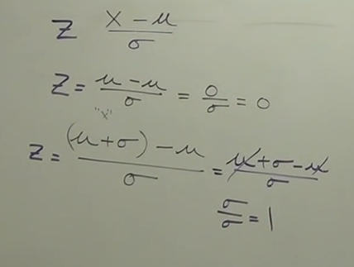

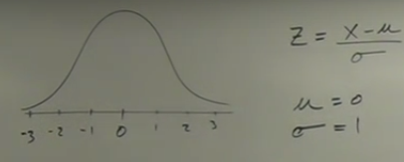
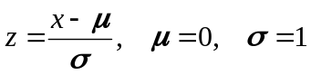

Example
Testing Thermometers
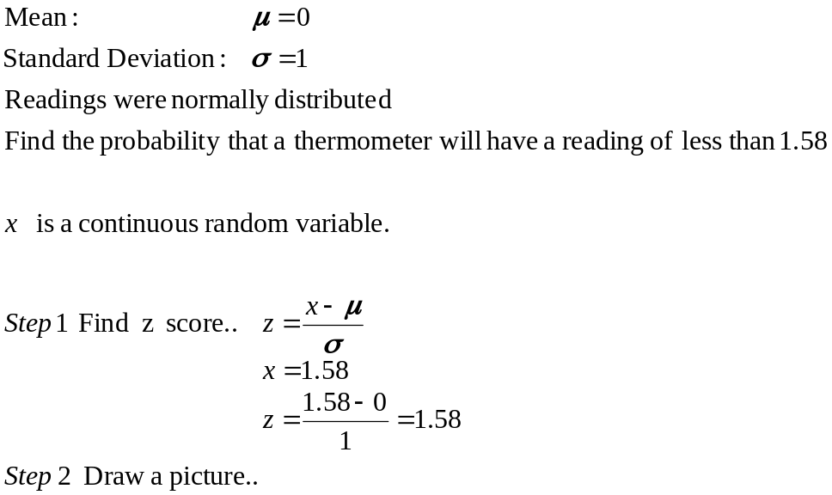

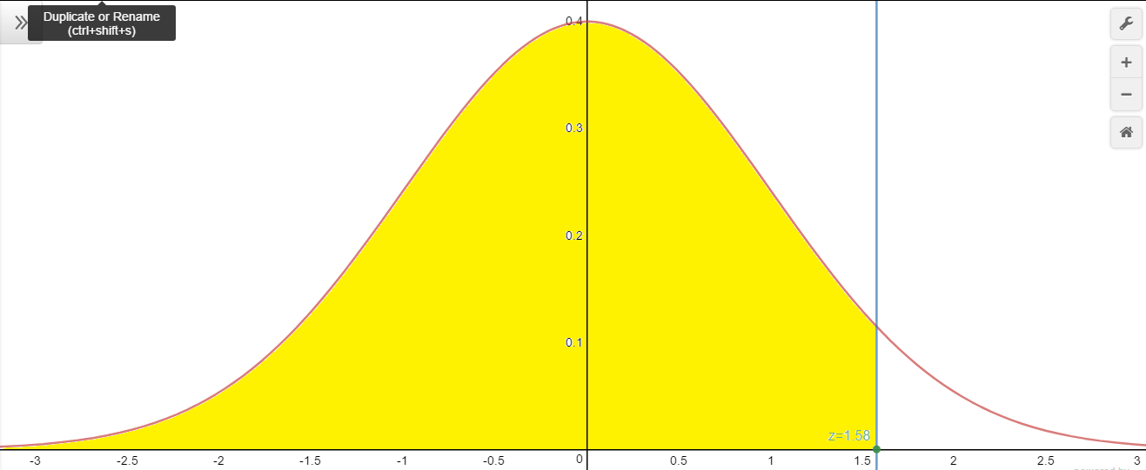
Area above = .9429 using Standard Normal Distribution table

It is 94.29 probability of selecting a thermometer with a reading of
Less than 1.58.

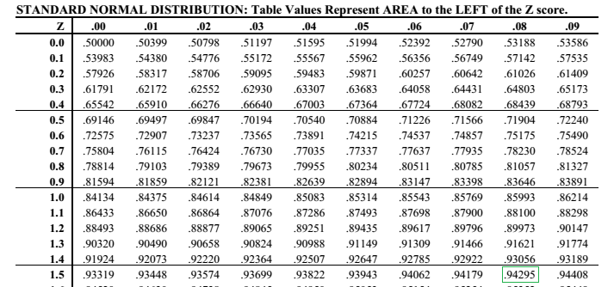
Example
Testing Thermometers

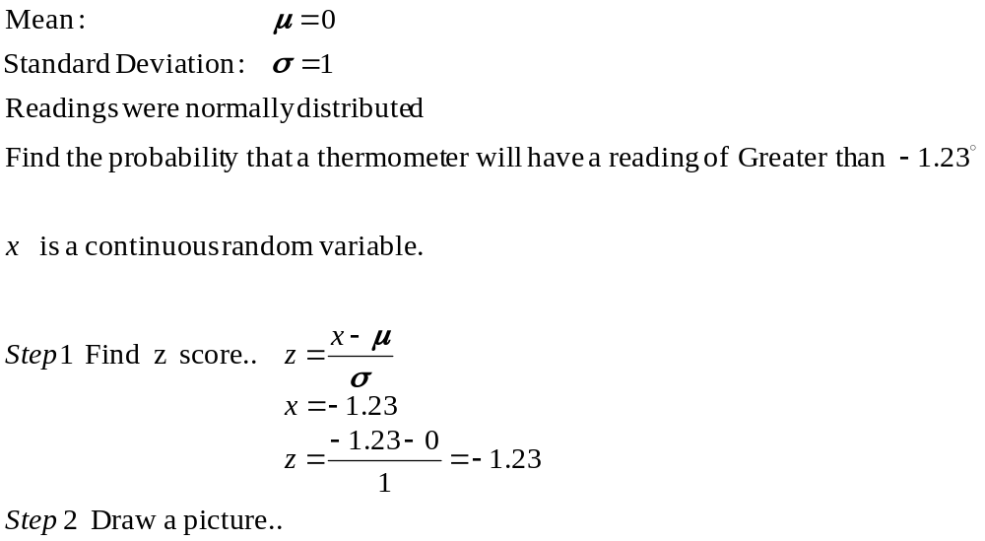
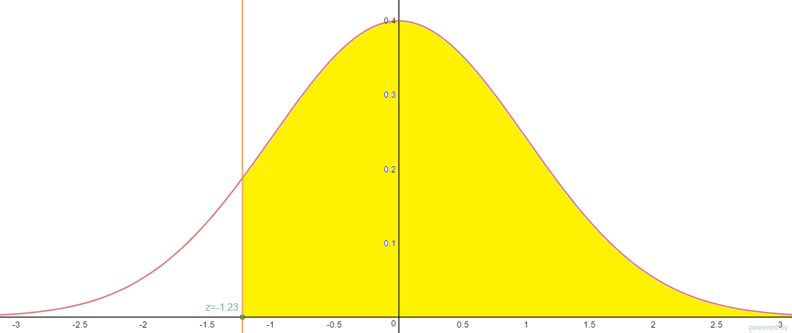
Area above = 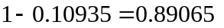 using Standard Normal Distribution table
It is 89.07 percent probability of selecting a thermometer with a reading of greater than -1.23.

Example
Testing Thermometers

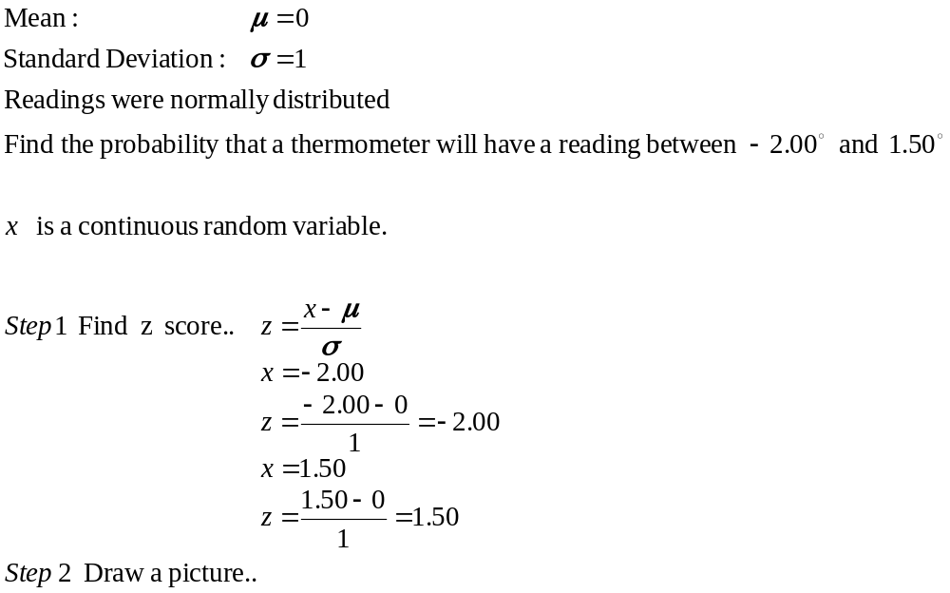

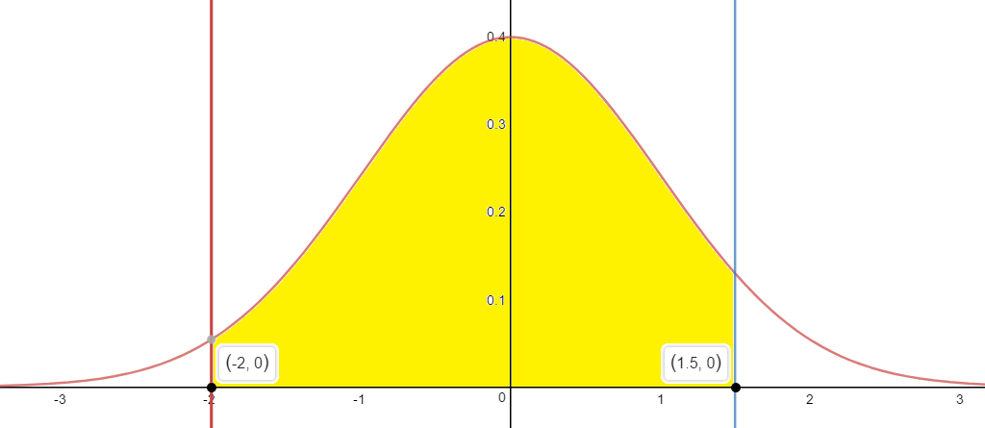
Area above = using Standard Normal Distribution table

Finding z scores from areas.
Work backwards by using an area (probability) to find the distance from the mean. (z-score)

- draw picture.
- Use table in reverse (or Calculator - inverse normal)

Example
Testing Thermometers

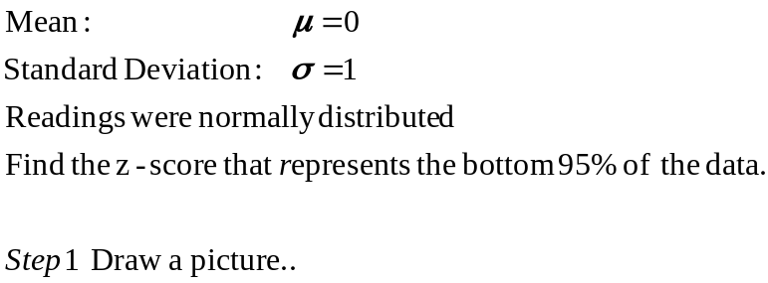

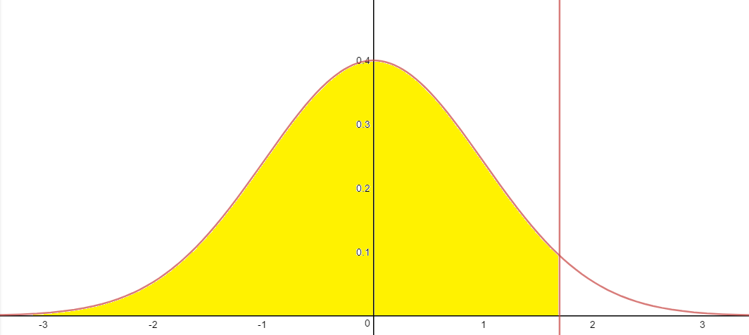
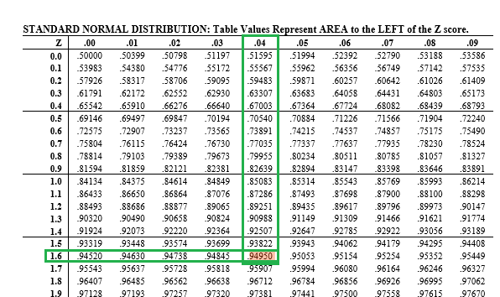
The z-score that represents the bottom 95% of the data is 1.64
So, 95% of all thermometers will have a reading of less than 1.64 degrees,

Top 30%--like saying bottom 70%

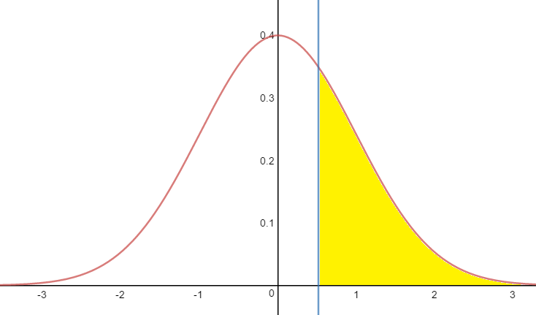
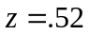

Bottom 10%

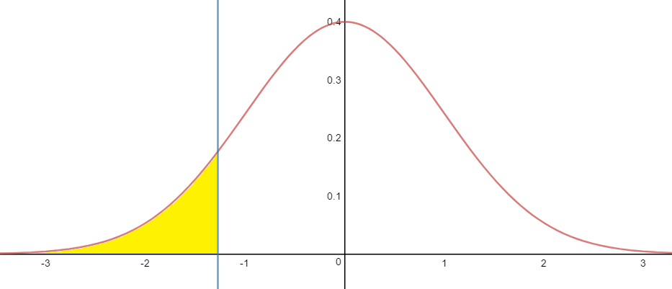
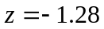

Top 80%--like saying bottom 20%

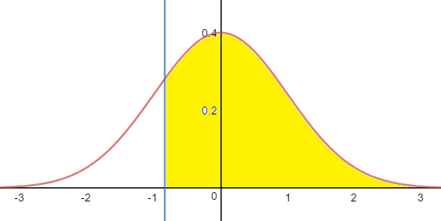
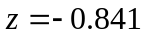

Example
Find the z-scores that give the area between the top 2.5% and the bottom 2.5%

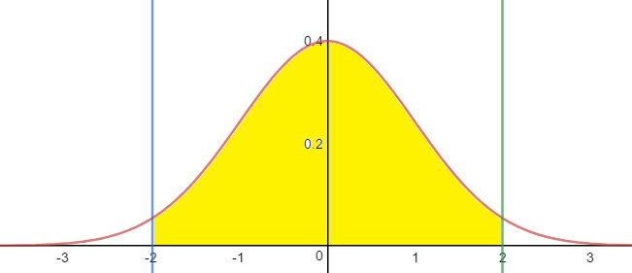
Z 